1.Check if a number is positive or negative
#include<stdio.h>
void main(){
int a;
printf("Enter a ");
scanf("%d",&a);

if(a<0){
printf("a is negative\n");
}
else if(a>0){
printf("a is positive\n");
}
else{
printf("a is equal to 0");
}
}

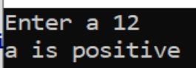
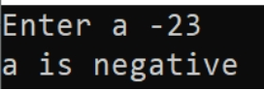
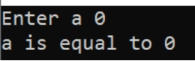

2.Find largest of three no’s using nested if
#include<stdio.h>
void main(){
int a,b,c;
printf("Enter a ");
scanf("%d",&a);
printf("Enter b ");
scanf("%d",&b);
printf("Enter c ");
scanf("%d",&c);

if(a>b && a>c){
printf("a is largest\n");
}
else if(b>a && b>c){
printf("c is largest\n");
}
else{
printf("c is largest");
}
}

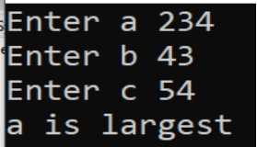

3.Assign grade based on marks
#include<stdio.h>
void main(){
int marks;
printf("Enter marks ");
scanf("%d",&marks);

if(marks<100 && marks>=90){
printf("Grade:A");
}

else if(marks<90 && marks>=80){
printf("Grade:B");
}

else if(marks<80 && marks>=70){
printf("Grade:C");
}

else if(marks<70 && marks>=60){
printf("Grade:D");
}

else if(marks<60 && marks>=50){
printf("Grade:E");
}

else if(marks<50){
printf("Passed class");
}

else{
printf("Wrong input");
}
}

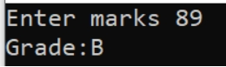
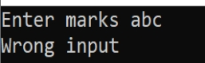

4. To check if a number is even or odd
#include<stdio.h>
void main(){
int a;
printf("Enter your no ");
scanf("%d",&a);
if(a%2 == 0){
printf("a is even");
}
else{
printf("a is odd");
}
}
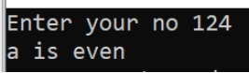
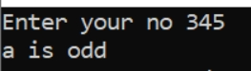

5.Simple calculator using switch case
#include <stdio.h>

int main() {
int choice;
float num1, num2, result;

printf("Enter two numbers: ");
scanf("%f %f", &num1, &num2);

printf("1. Addition\n");
printf("2. Subtraction\n");
printf("3. Multiplication\n");
printf("4. Division\n");
printf("Enter your choice: ");
scanf("%d", &choice);

switch(choice) {
case 1:
result = num1 + num2;
printf("Addition = %.2f\n", result);
break;

case 2:
result = num1 - num2;
printf("Subtraction = %.2f\n", result);
break;

case 3:
result = num1 * num2;
printf("Multiplication = %.2f\n", result);
break;

case 4:
if(num2 != 0)
printf("Division = %.2f\n", num1 / num2);
else
printf("Error! Division by zero.\n");
break;

default:
printf("Invalid choice!\n");
}

return 0;
}

Op:

Enter two numbers: 10 5
1. Addition
2. Subtraction
3. Multiplication
4. Division
Enter your choice: 3
Multiplication = 50.00

6. Check for leap year
#include <stdio.h>
int main() {
int year;
printf("Enter a year: ");
scanf("%d", &year);
if((year % 400 == 0) || (year % 4 == 0 && year % 100 != 0)) {
printf("%d is a Leap Year.\n", year);
} else {
printf("%d is NOT a Leap Year.\n", year);
}
return 0;
}
Op :Enter a year: 2024
2024 is a Leap Year.

